FEJS
  - NEWSLETTER
  - 24.04.17

World Book Day!

:

Reasons to celebrate!
The report from highlights how far the school has come since its’ last full inspection in 2014 and we are, most definitely, on the road to’good’.
Ofsted noted the following strengths:
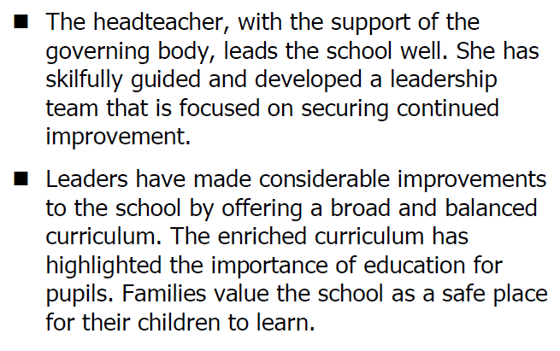

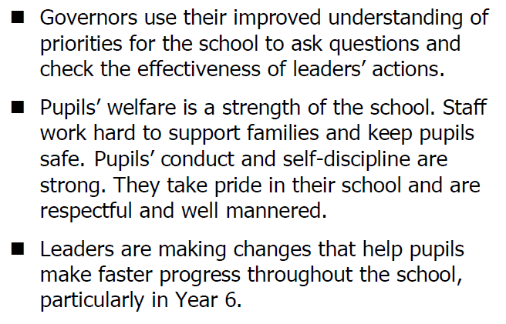

Attendance Matters
Good attendance matters. When children miss school, their learning really does suffer.
Please try to meet our target of 96% attendance. Our current school attendance lies at %.
It has been in the news recently about the father who took the local authority to court after being fined for taking his children out of school for a holiday. The father lost his court case therefore, can I urge everyone to arrange holidays during the school holidays? I have added a couple of training days to the October half term therefore this may give you a little bit of flexibility when booking your next holiday.

Many thanks to the children for visiting the residents of The Branksome Care Home. The children read some poetry and chatted over afternoon tea!
Safeguarding
Keeping children safe is our priority. We have a number of safeguarding procedures in school, as well as leaflets and information for parents. You can also obtain information about safeguarding from our website. If you have concerns about a child at our school, or need some support and you’re not sure which
way to turn then please feel free to contact Miss. Mellor, our School Liaison Officer who will be happy to help.
School Dinners – still terrific value!School dinners really are great value at just £2.00 a day, ensuring your child gets a balanced diet with a lot less fuss. Please collect a menu from the office.
Packed Lunches‘Thank you’ to all those parents who pack healthy lunches for their children. We are beginning to monitor lunches more carefully as it is our business to oversee that children develop healthy eating and improved lifestyle choices.
If you would like some support in doing so, please contact Emma Mellor or Mr. Neequaye, who will be happy to help. Don’t forget that we have a number of fitness clubs for children throughout the week including the child and parent fitness class that Mr. Neequaye runs every Monday morning.

Reminder: Playtime snacks
Playtime snacks are a great idea but please ensure that they are healthy. It is also recommended that your child brings a water bottle to school to keep them hydrated throughout the day.
Development of the premises
We hope you like the changes to our school grounds so far. The children love the new play equipment!
In addition, the school has also been successful in its’ bid for £40,000 to retarmac the playground. This will probably done over the summer holidays.
Our Parent Teachers Association have also been successful in their bid to fund parent cookery classes. Watch this space for further information to be sent out soon!
Our school in pictures!
World Thinking Day
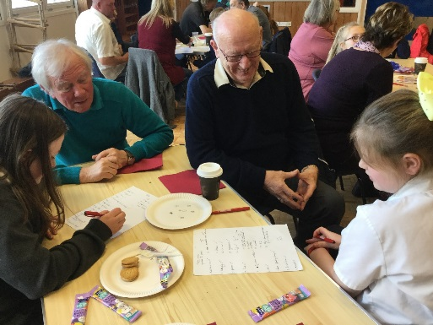
Grandparent’s Quiz!
Rev’d Carl gets the parents up to sing at our Easter Service!

Join our PTA! Without it, we will not be able to run the many events we usually hold in school such as discos, fairs and so on.
Many thanks to those who helped at the school disco! We raised £
Speak to Mrs. Mercer if you think you may be able to help too.
Thank you.

– The Qu

