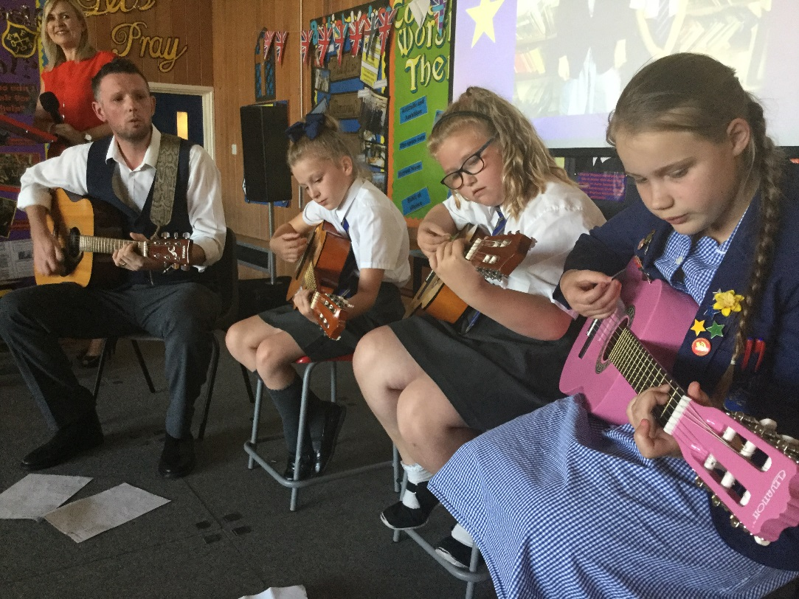 |  | FEJS  - NEWSLETTER  - 17.09.18

Enriching the curriculum!

WELCOME BACK
EVERYONE!
We’re back and ready to rock!
A warm welcome is especially extended to all of our new families whose children have joined us across the school!
It was marvelous to see the children return to school in their new uniforms. Everyone looks very smart!
Wanting the best for your child!
We want the best for your children so that they can continue to grow as learners throughout their school lives. In a massively changing world, your children have to compete for the best opportunities in life in order to secure their future happiness and economic prosperity and this is why we continue in our drive to improve our school and the life chances of your children.
The proof is in the pudding!
Our policies for improvement have been very successful so far, children are becoming better readers, spellers and mathematicians.
Our Year 6 SAT results have increased for the 3rd year running and are in line with national expectations and actually exceed this year’s national average in maths. Well done everyone!
We boast a fantastic range of extra clubs, in term time and during the holidays and have even pushed the boundaries by providing free wrap around care from 8am until 530pm daily to support working parents, saving you hundreds every month!

Continuing to raise expectations
You can help your child to succeed by
- Listening to them read regularly, at least 4 times a week.
- Helping them to learn their spellings every week. Children are required to get at least 18 out of 20 in their Friday test.
- Helping them to learn their timetables. This helps them to make better progress in their maths lessons. The national expectation is that children should know all their timetables by Year 4!
- Ensuring they are school ready by having the correct uniform and PE kit [& swimming if in Class 4T this term].
- Ensuring children are emotionally equipped to learn, are fed breakfast and have good attendance and punctuality.
Please remember, if you require any support; we are always here to help. Contact Miss. Emma Mellor.
Good news
Our school budget is healthier than most at the moment which means which can continue to provide current services without feeling the pinch such as subsidizing some clubs & trips, maintaining staffing levels, providing the children with quality resources and improving the learning environment.
Attendance Matters
Good attendance matters. When children miss school, their learning really does suffer.
Poor attendance also comes under the Anti-social Behaviour Act 2003 and parents can be issued with penalty notices of £100 per person.
We ask that parents do not take their children on holiday during term time.
I understand that holidays tend to be cheaper during term time and I know how important it is to have family holidays but I can only give permission in exceptional circumstances. Holidays will be closely monitored by myself and the Education Welfare Officer and that includes holidays not authorized whether you have made a request to the school or not.
Requests are also likely to be accepted
I have taken a number of steps to ease the financial strain put on families by providing free wrap around care for working families and have added training days onto the October, Christmas and February half term holidays to give that little bit of flexibility when booking holidays.
Please pop in and see me if you have any queries, I will always listen to your concerns.
Celebrating 100% Attendance

Use of social media
Please do not undermine the good work of your child’s school on social media. It demoralises staff, parents and pupils. The local authority supports this strict stance and can take legal action if necessary, especially if staff or pupils are named or can be identified
Instead, contact me and I will be happy to listen with understanding, to the concerns you may have.
Please follow the school’s Complaints Procedure Policy, a copy of which is on our website, if you have a grievance you wish to air, so that your voice can be heard using the correct protocol.
We also welcome compliments and suggestions.
Thank you for your support in this matter.
Safeguarding

Keeping children safe is our priority. We have a number of safeguarding procedures in school, leaflets and information for parents. You can also obtain information from our website. If you have concerns about a child at our school, or need some support and you’re not sure which way to turn then please feel free to contact Miss. Mellor, our School Liaison Officer who will be happy to help.
Parking outside school
Please park safely and considerately and never on the yellow lines.
Playtime snacks
It’s a great idea to send your child to school with a healthy playtime snack. It is also recommended that your child brings a water bottle to school with them to hydrate throughout the day.
Packed Lunches
Families are required to pack a healthy lunch for their child. Please avoid chocolate and big bags of crisps. Fizzy drinks are not allowed.A healthy packed lunch could include any of the following: sandwiches, crisps, fruit and dried fruit, a biscuit, yoghurt, salad, vegetables and water.
School Dinners – still terrific value!
We have a new school cook, Joanna, who has made the most fabulous lunch today! School dinners are still great value at just £2.10 a day, ensuring your child gets a balanced diet with a lot less fuss. Please collect a menu for the office.
Staffing
We welcome Mrs. Fletcher and Miss. Owen to our team here at Fairfield. Both will be working as relief Lunchtime Organisers from the start of term.
Curriculum – Our school priorities
Our focus this year is developing writing across the curriculum.
Teaching the wider curriculum is also of great priority this year. We are investing a great deal of teacher training time in ensuring that national objectives are being met but also, we’re trying to make these areas of the curriculum as exciting as possible by introducing many more learning experiences outside of the classroom.
Our recent trip to Derby
We visited The Open Centre to find out about Judaism and Islam.
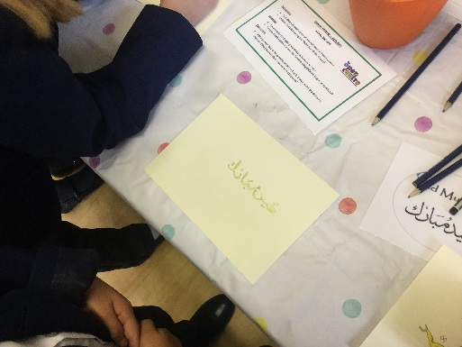
We wrote our names in Arabic
We dressed in the Jewish prayer shawl called a tallit and wore a skull cap called a kippah.

We also visited Grin Low Woods
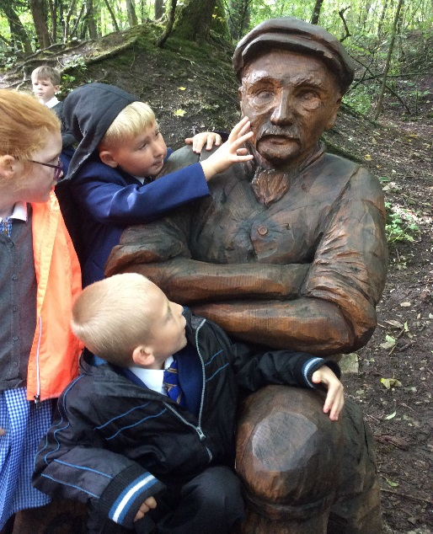
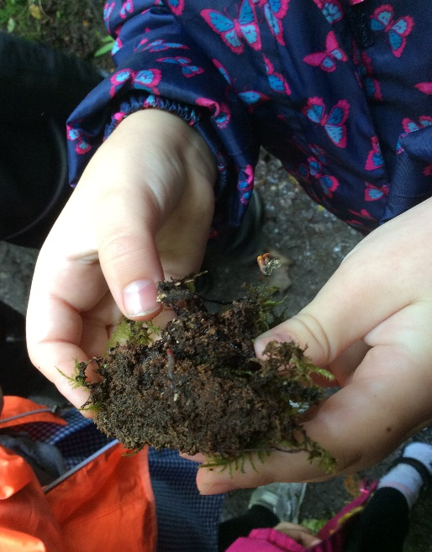

…and Poole’s Cavern
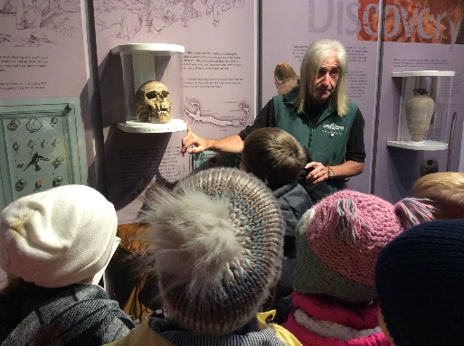
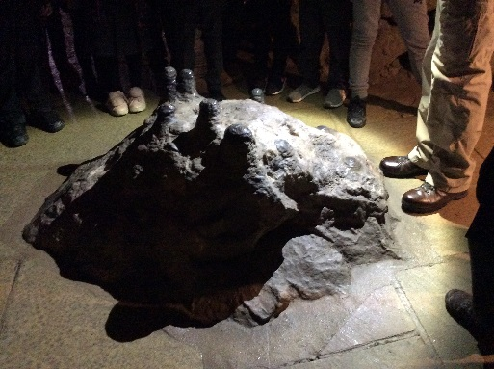
Our focus author this term is Roald Dahl
We are encouraging the children to read as many of his books as possible whilst Year 3 children make it a particular focus in the classroom.

School refurbishment
Over the summer, we have transformed the old ICT suite into a new ‘learning zone’ where children can use non-fiction books and ICT software to investigate history, geography and science. This reinforces our belief in the teaching of foundation subjects, which are being given a high priority here at Fairfield, and are as important as any other learning experience for our children.

Dairy Dates so far [please check website for more]
September
5th – Lea Green meeting for parents at 6pm
10th – School photographs
11th – Year 5 & 6 Faith Tour of Derby
12th – Year 3 & 4 trip to woodland near to Poole’s Cavern
13th – Roald Dahl Day
17th to 19th – Year 6 away at Lea Green
17th – Parents Evening for those going to Buxton High School at 6pm at Fairfield
18th – Years 3 & 4 Faith Tour to Derby
19th – Year 5 at Macclesfield Forest
21st – Harvest Festival Year 4 at St.Peter’s Church at 9.30am
28th – MacMillan Coffee Afternoon – invites out shortly
October
10th Parents Evening 2.30pm onwards
15th Raising Aspirations trip to Derby University
16th – Restart a Heart Day
22nd - Fire Safety training for Year 6
23rd – Flu vaccinations
24th – Indian dance workshop
25th & 26th – school closed for training days
November
16th – 9.15am Year 5 curriculum assembly for children and parents
16th- 2.30pm Year 6 curriculum assembly for children and parents
18th – Year 5 trip to Tatton Park for Viking topic
December
20th – Year 3 Christmas Event

