FEJS
  - NEWSLETTER
  - 08.01.19

Very proud of our school choir singing at St.jonh’s church in buxton!

appy New Year!
Happy New Year!
Welcome back everyone, I hope you all had a lovely Christmas! We’re all looking forward to another great year at Fairfield as we welcome 2019!
Striving to be the best!
As a parent myself, I understand how we all want the best for our children. Working together ensures that your child reaches their full potential, experiences success in learning and ultimately feels proud of what they achieve.
This term, we’re going to have a massive push on reading-learning to love reading and how it can unlock so many barriers in life.

The importance of reading-our focus this term
Our children develop reading skills every day in school. We like to encourage them to use their reading skills across the curriculum and to choose reading as a pastime that could rival playing on the XBOX or the posting pictures on Instagram [we can try!].
Our whole school reading target this term is being able to summarise what we have read.

We ask that you support your child by:
- Listening to them read at least 4 times a week, even if your child is in Year 6. It really does help to build confidence in speaking and in tackling unfamiliar words.

Children in Yr’s 3 and 4 should aim to read for 15 to 20 minutes a night whereas children in Yr’s 5 and 6 should aim to read for between 20 & 30 minutes a night. Doing this will aid the enjoyment of the book and allow children to become emersed in the text.

Don’t forget to write a comment and/or sign your child’s reading record book, letting us know that your child has read as this builds up rewards for your child and allows them to earn points towards badges for their blazers and golden time each Friday.

Thank you
for your support!

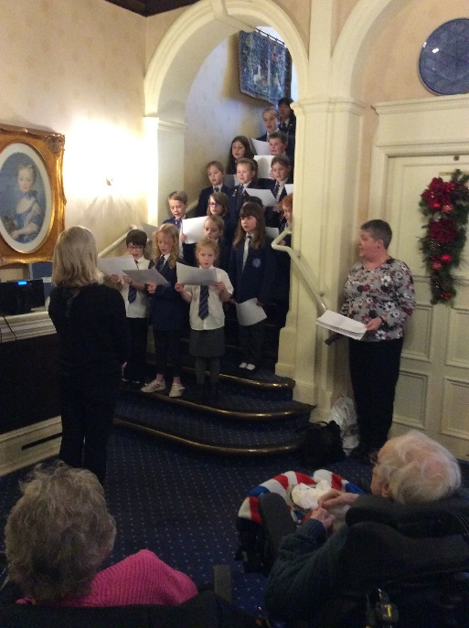
Our School Choir sang beautifully for the residents of the Branksome.
Safeguarding
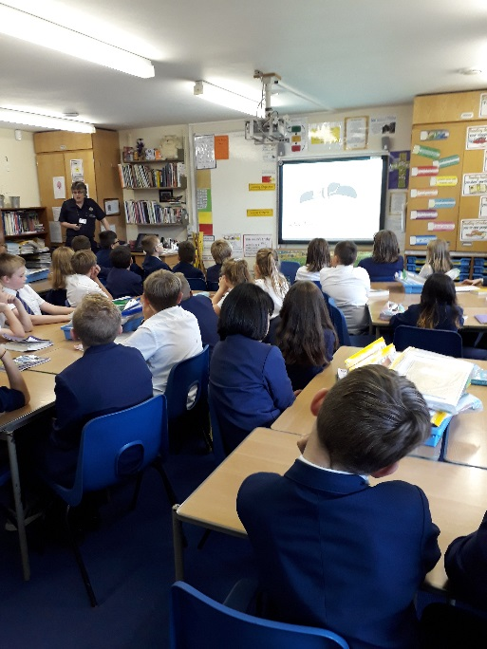
Keeping children safe is our priority. Below is a picture of our Year 6 children receiving a fire safety talk from the Fire Brigrade.
Don’t forget, we have our own Family Liaison Worker if you feel you need support with anything. We’re always happy to help.
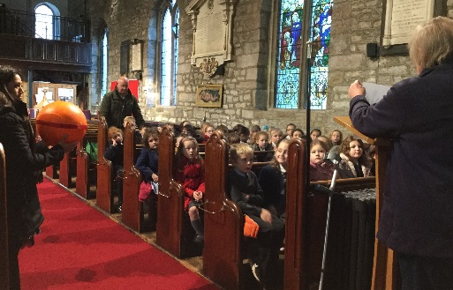
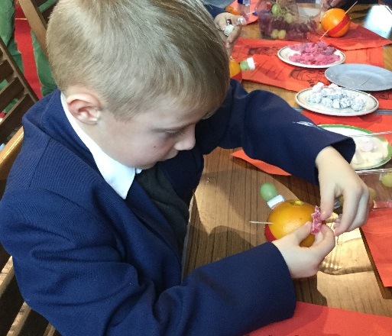
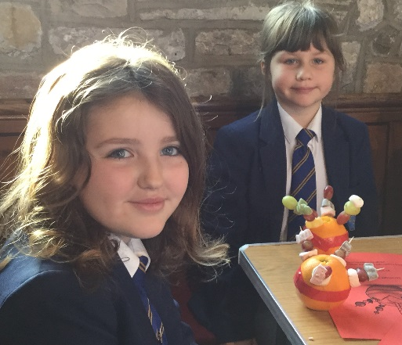
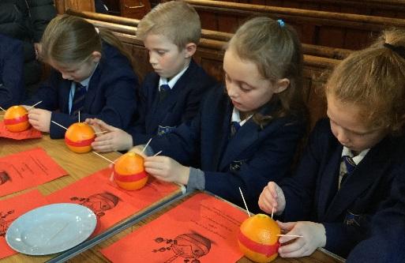

Year 3 children hard at work making Christingles at St.Peter’s Church.
Attendance Matters
Good attendance matters. When children miss school, their learning really does suffer.
Poor attendance comes under the Anti-social Behaviour Act 2003 and parents can be issued with penalty notices.
The current government has stipulated for a number of years now that holidays are not allowed to be taken during term time hence the law supports local authorities in fining families for holidays not authorised by the school. The school can only authorise holidays in exceptional circumstances such as those taken with termilally ill family members or friends or because of a parent being allocated specific holiday times by their employees [in this circumstance, the family member must provide the school with a letter from their employee on letter headed paper giving details of the reason].
Fines will be issued to families for not complying with the rules, whether you have filled in a holiday request form or not, should it be revealed at a later date that time has been taken for a holiday during term time as your child’s absence will be classed as unauthorised.
I thank you for your understanding in this matter.

Here are a few pictures, taken last term, of children taking part in the wider curriculum.
Year 6 and their topic on World War 2.
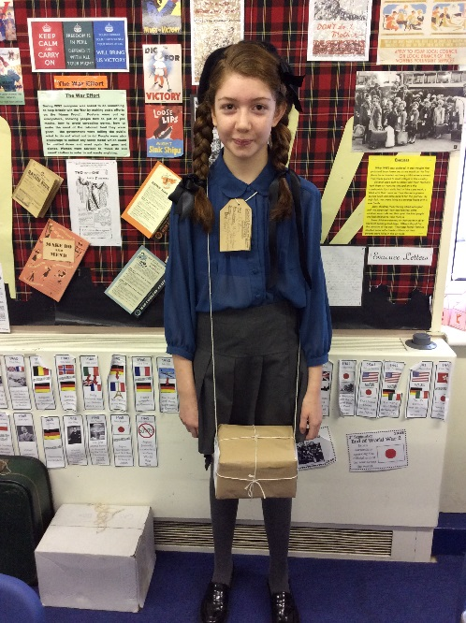
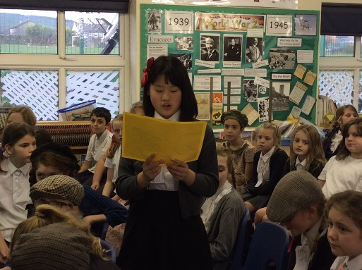
Year 3 – archaeological digging as part of their topic on early Britain.
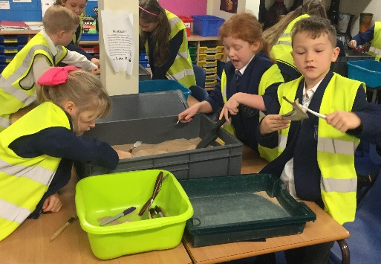
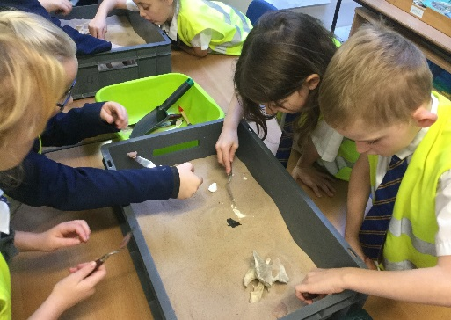
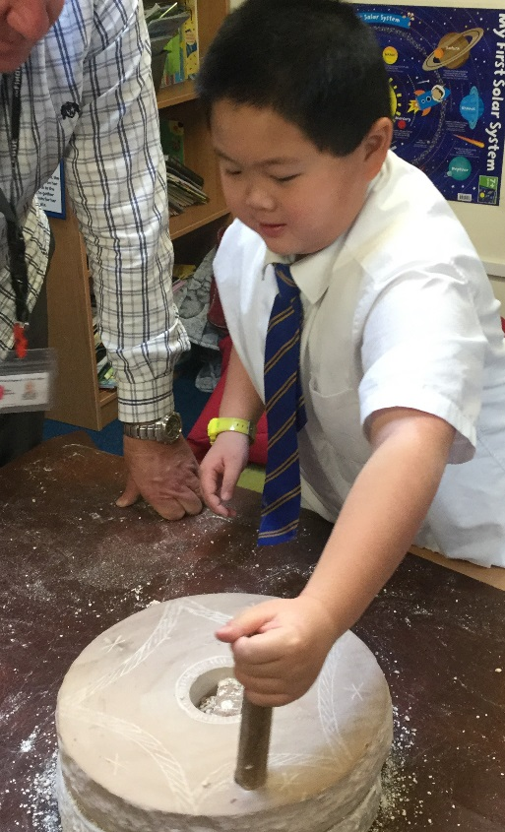
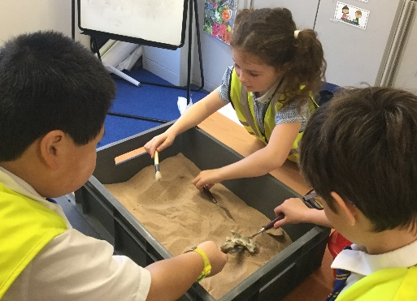
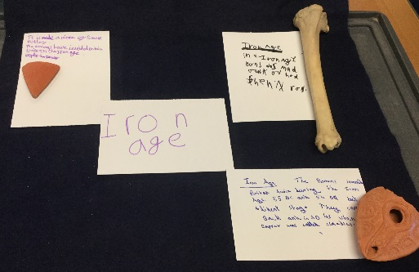
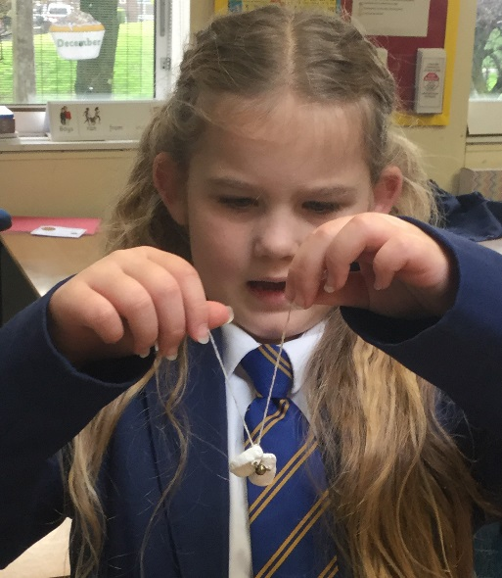

Year 5 Viking Warriors- singing and making.
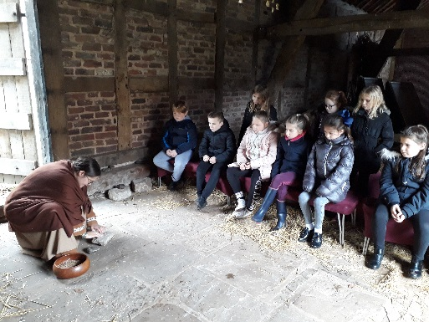
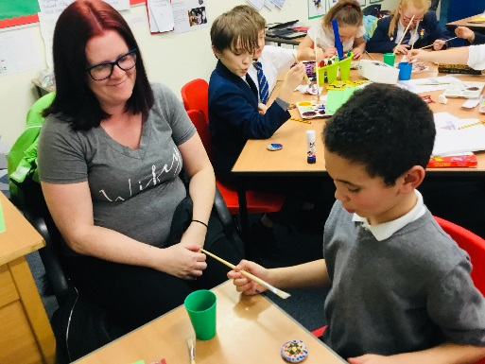

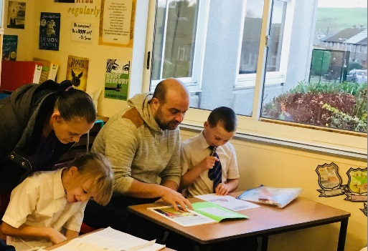

Year 4 enjoy their trip to Chester as part of their topic on the Romans!

Playtime snacks - reminder
It’s a great idea to send your child to school with a healthy playtime snack. It is also recommended that your child brings a water bottle to school with them to hydrate throughout the day.
Packed Lunches
‘Thank you’ to all those parents who pack healthy lunches for their children. We monitor lunches in order to encourage healthy eating habits and healthy lifestyle choices amongst our children.
If you want more support in doing so, please contact Emma Mellor or Mr. Neequaye, who will be happy to help. Don’t forget that we have a number of fitness clubs for children throughout the week including the child and parent fitness class being run by Mr. Neequaye every Monday morning.
School Dinners – still terrific value!
School dinners really are great value at just £2.10 a day, ensuring your child gets a balanced diet with a lot less fuss. Please collect a menu from the office.
Please join your PTA!
Speak to Mrs. Mercer if you think you maybe able to help.
Thank you.

