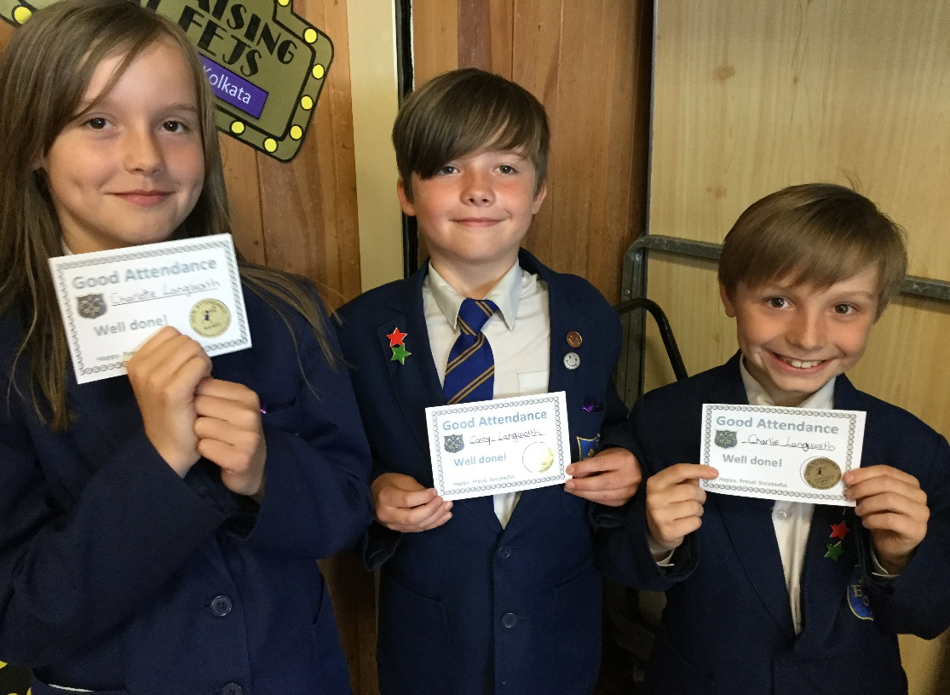 |  | FEJS  - NEWSLETTER  - 08.06.18

Celebrations! A whopping 104 children got 100% attendance. Well done!

appy New Year!
Attendance Watch!
Here is last term’s attendance for each class. Our target is 96% and you can see that there are many classes meeting this expectation, well done everyone!
3H – 94% [96% from September]
3S – 97% [96% from September]
4H – 98% [97% from September]
4T – 96% [96% from September]
4W – 96% [96% from September]
5P – 96% [95% from September]
5R – 95% [95% from September]
6J – 98% [97% from September]
6P – 93% [94% from September]
Whole school is 95.70%, just below the target.

Reminders:
Leave of absence [for a holiday, as an example] is only granted in exceptional circumstances at the discretion of the Headteacher.
An ‘exceptional circumstance’ leave of absence form can be collected from the office.
Where a request form has not been submitted or has been turned down, absence from school will be logged as unauthorised.
Please…
-avoid term time holidays if you can.
-please inform other family members of the school’s policy on attendance.
Other reminders:
Please contact the school to report your child’s absence before 8.50

am. The school office opens at 8.30am to take your calls.
Text messages will no longer be accepted for safeguarding reasons.
If we do not hear from you, your child’s absence will automatically be recorded as unauthorised.
The Education Welfare Officer works closely with the school to improve attendance.
Medical appointments The good news is that medical appointments can be made within school time, in between registrations preferably [after 9.15 and after 1.20] in order to help your child’s attendance remain good.
In order to highlight the importance of good attandance to the children, the best attending class each week will get to sit on the benches in assembly. A special assembly is also held each half term when awards are given for out good attendance.
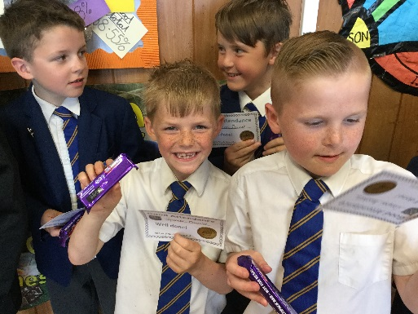
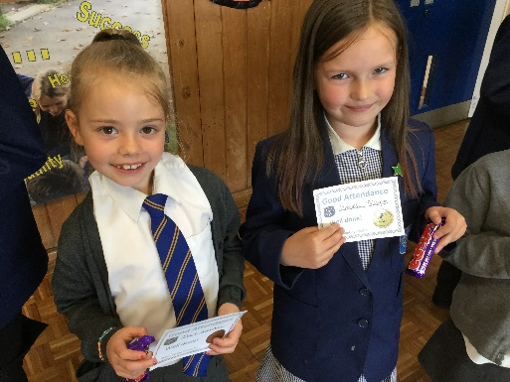
Children celebrating good attendance!

If you need support in trying to improve your child’s attendance then maybe we can help. Pop in or give us a call on 22551. Miss. Emma Mellor will be available most of the time.
Royal Wedding Celebrations
We joined in with the celebrations, in our own way as you can see from the pictures. Thankfully, it was a sunny day and we could picnic outside.

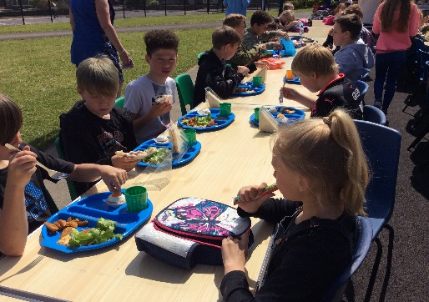
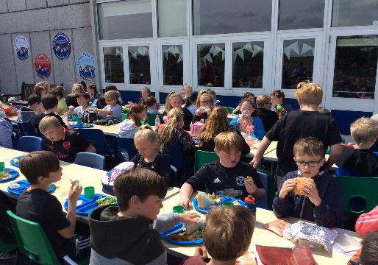

Stop Press
HMI VISIT
Please see below, the main points from our latest HMI inspection. The full document can be read on our website.
It was recognised that
- leaders work tirelessly to improve the school.
- there is a clear sense of positivity among the school community
- teachers give the pupils challenging work
- pupils make fast progress overall
- attainment of pupils is rising
- pupils are moved on quickly to learn new things
- pupils make good gains in their phonic knowledge
Thank you to everyone for your support and thank you to the staff and pupils for all their hard work!

