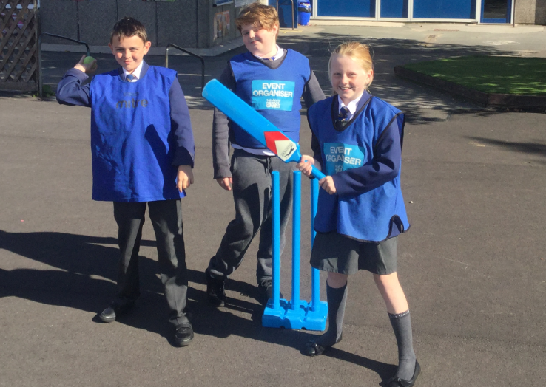 |  | FEJS  - NEWSLETTER  - 05.11.18

Our Playground Buddies are here to help as we prepare for national anti-bullying week from 12th November!

WELCOME BACK
EVERYONE!
Welcome back to the second half of the autumn term and run up to Christmas!
As always, we’ve got lots to celebrate and lots to look forward to.
The serious stuff!
Attendance Matters
We ask that parents do not take their children on holiday during term time.
Good attendance really does matter! When children miss school, their learning really does suffer. Every day of every week, lessons link with each other. Tuesday’s literacy lesson links on from Mondays and so on. When you child misses a day or a week, it affect their confidence in the next lesson as they will have missed a learning point.
Poor attendance also comes under the Anti-social Behaviour Act 2003 and parents can be issued with penalty notices of £100 per person.
Please see the school website for more information about attendance.
Playtime snacks
It’s a great idea to send your child to school with a healthy playtime snack. It is also recommended that your child brings a water bottle to school with them to hydrate throughout the day.
Packed Lunches
Families are required to pack a healthy lunch for their child. Please avoid chocolate and big bags of crisps. Fizzy drinks are not allowed.
A healthy packed lunch could include any of the following: sandwiches, crisps, fruit and dried fruit, a biscuit, yoghurt, salad, vegetables and water.
Safeguarding

Keeping children safe is our priority. We have a number of safeguarding procedures in school, leaflets and information for parents on our website. You can also obtain information from our website. Miss. Mellor, our School Liaison Officer is also happy to help.
Parking outside school
Please park safely and considerately and never on the yellow lines.
We’re here to do everything we possibly can for your child. Please come in and talk to us about your child’s learning. In bringing your child here, to Fairfield Juniors, there’s an expectation that we work together towards the best possible outcomes for you child.
We therefore have the following expectations of all parents:
1.Listen to your child read regularly, even the year 6’s!
2.Encourage your child to learn their spellings – remember, children are expected to get 18 out of 20 in their spelling test each week.
3.Help your child to learn their times-tables. By Year 4, children across the country are expected to know all their time-tables.
Other things to help your child get the best out of their day at school
4.Ensure your child has healthy breakfast [and packed lunch] – nobody can concentrate when hungry!
5.Ensure your child has had enough sleep – the early bird catches the worm! It’s also a good idea to avoid the use of game consoles in the morning as these have been found to increase anxiety.
6.Ensure your child wears the correct school uniform and keeps the correct PE kit in school, all term.
7.Don’t arrange holidays in term time. Every Literacy and Numeracy lesson links to the following day. A unit of work usually lasts about 3 weeks so a week off can seriously affect their learning as they may miss something that will not be repeated.
Time to Celebrate!
Pupil outcomes-reasons to celebrate
Our SAT results have increased over a three year trend having achieved higher than the national average this year. This means that our children are making terrific progress.
Reading - 74%
Writing - 74%
Maths - 81%
We’re really proud of the children’s achievements which prepare them well for high school and a massive ‘thankyou’ to all the parents who support the school’s drive to improving the life chances of our children.
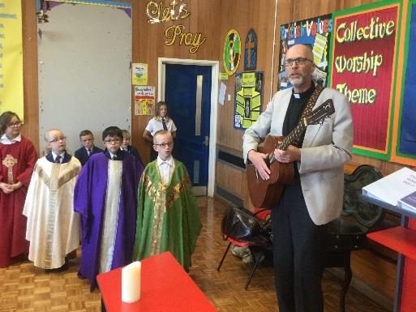
Celebrating our links to the Church
Rev’d Carl delivers an assembly and a song we all love to sing!

Curriculum – Our school priorities
Global Awareness and the Wider Curriculum

An important part of our curriculum is to encourage the children to learn as much as possible about the world in which they live.

This is achieved through our many of the subject areas we teach but, in particular through PSHE, RE and Science.

The new Learning Zone
This room has been established to encourage an understanding of the world. In it, you’ll find books linking to history, geography, science and RE. There are maps, posters and artefacts/models linked to all kinds of learning. The children are free to use ipads to encourage curiosity and investigative skills. There are even clocks on the wall displaying different time zones around the world! You’re welcome to pop in and have a look around.

Aspirational opportunities

Some of our Year 5’s and 6’s recently attended an event at Derby University, giving them an opportunity to find out what life and learning at university is like. The children had a wonderful day. See the website for more information about this fabulous day!

Indian dancing
Last term, as part the RE curriculum, children had the opportunity to dance Indian traditional dancing. They had a wonderful time. Log on to the website to see your child in action!
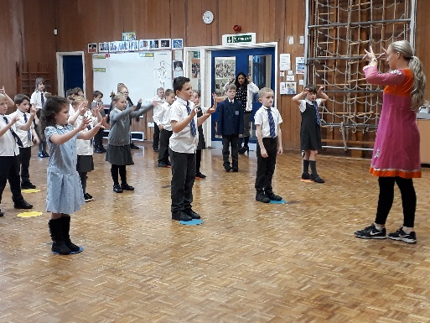

Map Quest
Children in Year 4 recently took part in an activity in Pavilion Gardens linked to Geography. Map Quest is an orienteering event to encourage children to explore, navigate & map read.

Competitions
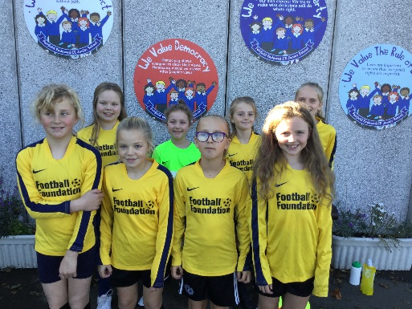
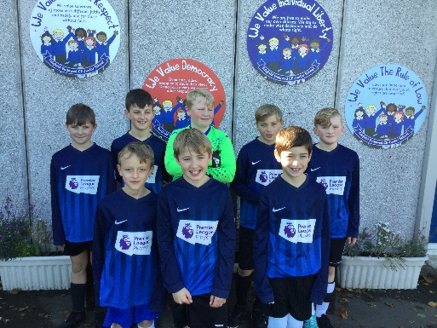

Our girls football team won the High Peak football competition & have progressed to represent the High Peak in the Regional finals.
The boys team came a very respectable 3rd in the High Peak football competition.

Keeping safe - road skills
Children in Year 5 have taken part in the bikability project, learning how to ride safely on the roads. They all passed. Well done Year 5! Remember: Always wear a helmet when riding out.

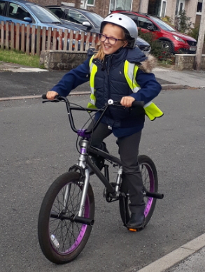

Anti-bullying Week
Next week, the school will raise awareness of bullying and what to do if bullying occurs. We already have safety stations in school where children can gather information about what to do, who to talk to etc. The children also have access to an anti-bullying leaflet, designed by the children themselves, last year. These are situated around the school and in every classroom. In a recent questionnaire, all parents were confident that the school deals with bullying appropriately. Some were not sure therefore we hope the enclosed information helps.

Charity
The children have decided that our chosen charities for the year are Blythe House, Night Stop, Calcutta Education and The Donkey Sanctuary. The school will hold different events throughout the year. The school also held a MacMillan Coffee afternoon to help those with cancer. Thank you to everyone who took part. We raised £97.50!

Diary Dates so far [please check website for more]
November
8th – Year 5 trip-a Viking Experience
8th – Rev’d Carl Edwards delivering a Remembrance Assembly at school. Parents welcome to join us.
9th – Drop in for parents re Purple Mash with Mrs. Hewson.
11th – Remembrance Service at St. Peter’s. Members of staff attending. Please join us if you can.
12th – Anti-bullying Week
13th – Year 4 trip – a Roman Experience
14th – Open Afternoon for new parents 2 – 5.30pm.
15th – Children in Need Day. Wear something spotty!
16th – 9.15am Year 5 curriculum assembly for children and parents
18th – Year 5 trip to Tatton Park for Viking topic
December
7th – Year 6 Curriculum Assembly, parents welcome to attend at 2.30.
Some of the comments from parent’s evening!

- My child enjoys coming to school and is doing really well with his learning.
- Fantastic school, Great results.
- Our daughter in Year 6 has thrived so well at FEJS, we couldn’t be more pleased. Our other daughter in Year 3 has just embarked on her journey at FEJS and loves it so far! Excellent school and marvelous teaching.
- Absolutely outstanding school! Excellent levels of teaching and support. Warm, friendly atmosphere where teachers and staff are approachable and accommodating. Thank you!
- We have had a great start to year 3 and we are happy with the progress.
- I am happy with how my child has settled in at Junior school.
- It is really positive to see how well my child has settled in. We look forward to seeing her progress at Fairfield and will do our best to continue to encourage her.
- Great feedback! Thank you.
- I am very pleased with his progress so far in year 5, he really enjoys school and telling me all the new things he’s learned. He has a positive attitude towards school.
- I am very happy at how my daughter has settled in at Junior school. She is always very cheerful about school and says how much she likes it. I am happy with her progress and how she is taking Junior school in terms of feelings.
- I am really pleased how well my daughter is coming on in year 3. We are very proud.
- Very good parents evening, any concerns were answered for me well. Thank you.
- I am happy with the way my son is being taught and the help he is getting.
- What a fabulous parents evening.
- Very pleased with my child’s start in Year 6. He is comfortable and happy in school. I have no concerns. Fab parents evening.
- We could not be more pleased to hear how well our daughter is doing so far in year 6! She has consistently maintained high levels of achievement throughout her time at FEJS, this is down to the excellent teachers and support staff – thank you!
- We are delighted to hear that our daughter is progressing well in school. She is enjoying year 3 so far and hope she continues to do so and do well too. Thank you for your support in teaching her.
- My child has settled in really well. I am happy with his attitude to school.
- My child is enjoying school; I think this helps with his learning. He is very positive about everything he learns. It makes me smile when I see how animated he gets about things, he is very excitable and it’s lovely as a parent to see.
- We were very pleased with our child’s parents evening and proud she is doing so well. It was the best move moving her to Fairfield. I think the school is fantastic and she is loving it here.
- A good parents evening with honest feedback and realistic targets for our child and us to work towards together.
- Brilliant school, teachers and staff. Nothing bad to say regarding FEJS whatsoever.
- It was the best thing we did changing our child to this school. It is 100% better than the last one. I would recommend this school to anyone.

Thank you for all your support!

19th – Christmas Dinner Day
19th – Christmas Disco
20th – Year 3 Christmas Event in school,
parents welcome.

