FEJS
  - NEWSLETTER
  - 05.01.18

Children light the Advent Calendar at St.Peter’s church

appy New Year!
Happy New Year!
Welcome back everyone! I hope you all had a lovely Christmas and we look forward to working with you and supporting your children for the rest of the academic year.
Raising expectations
As a parent myself, I understand how we all want the best for our children. Working together ensures that your child reaches their full potential, experiences success in learning and ultimately feels proud of what they achieve.
It is for this reason that we want you to share in our mission to ensure that all children develop high levels of competencies in the basics of learning to read, spell well and understand number, place value and the 4 calculations of addition, subtraction, multiplication and division.
The importance of reading-our focus this term
As you will be aware, we place a lot of emphasis upon reading. There isn’t a school in the country that doesn’t!.

Our children read and develop reading skills every day in school. They complete comprehensions and use their reading skills across the currlculum.
Our whole school reading target this term is being able to summarise what we have read.

We ask that you support your child by:
- Listening to them read at least 4 times a week, even if your child is in Year 6. It really does help.
Children should be encouraged to read for increasing lengths of time. For example, those in YR 3 and 4 should aim to read for 15 to 20 minutes a night whereas children in YR 5 and 6 should aim to read for half an hour each night.
- Completing comments about your child’s reading in their reading record book.
- Helping your child to summarise what they have read.
Thank you for your support!

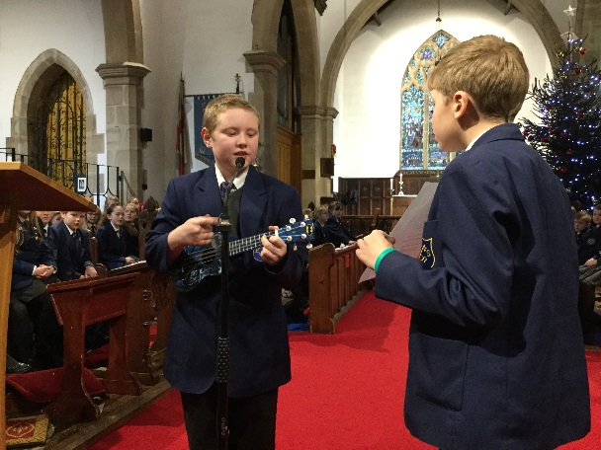
Playing the ukulele in Church!
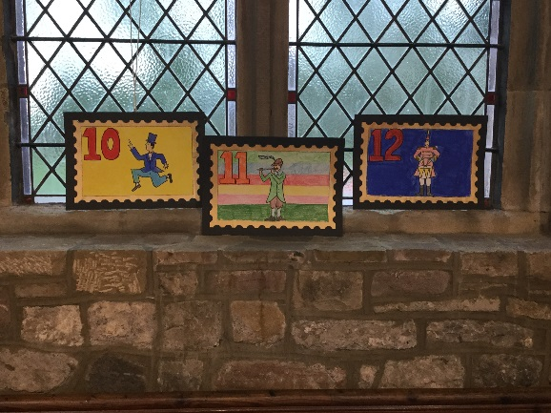
Some of the children’s beautiful art work displayed in St. Peter’s Church!
Our children read clearly & played the instruments beautifully!
Safeguarding
Keeping children safe is our priority. We have a number of safeguarding procedures in school, as well as leaflets and information for parents. You can also obtain information about safeguarding from our website. If you have concerns about a child at our school, or need some support and you’re not sure which way to turn then please feel free to contact Miss. Mellor, our School Liaison Officer who will be happy to help.
Homework- spell well!
All children receive 20 spellings a week which they must learn for testing on Friday. Children are expected to get at least 18 out of 20 therefore please encourage them to learn their spellings a little each night instead of leaving it until Thursday night.
Attendance Matters
Good attendance matters. When children miss school, their learning really does suffer.
Holidays will, this year, be closely monitored by the Education Welfare Officer.
Poor attendance also comes under the Anti-social Behaviour Act 2003 and parents can be issued with penalty notices.
Fines will be issued to families for not complying with the rules, whether you have filled in a holiday request form or not, should it be revealed at a later date that time has been taken for a holiday during term time as your child’s absence will be classed as unauthorised.
The Education Welfare Officer will be visiting this term and contacting families regarding their child’s attendance. Please contact the school if you need support in improving your child’s attendance, we’re always happy to help.
I thank you for your understanding in this matter.
Our School Choir singing at St.John’s Church at Christmas!
Playtime snacks - reminder
It’s a great idea to send your child to school with a healthy playtime snack. It is also recommended that your child brings a water bottle to school with them to hydrate throughout the day.
Packed Lunches
‘Thank you’ to all those parents who pack healthy lunches for their children. We are beginning to monitor lunches more carefully as it is our business to oversee that children develop healthy eating and healthy lifestyle choices.
If you want support in doing so, please contact Emma Mellor or Mr. Neequaye, who will be happy to help. Don’t forget that we have a number of fitness clubs for children throughout the week including the child and parent fitness class being run by Mr. Neequaye every Monday morning.
School Dinners – terrific value!
School dinners really are great value at just £2.00 a day, ensuring your child gets a balanced diet with a lot less fuss. Please collect a menu from the office.
Diary Dates
January 15th – Governors Meeting 4pm & 6pm.
22nd January – Drumming demonstration for parents of children in Mr. Redman’s class at 2.30pm.
Week beginning February 5th – Safer Internet Week.
Monday 12th February – Governors Meeting 6pm.
Tuesday 13th February – History Squad in Year 4 [for children only]
Wednesday 14th February – Valentine’s Disco
Thursday 15th February – school closes for half term.
Next Year’s training days will be held on 25th & 26th of October, 7th December, 25th & 26th February.
Please join our PTA! Without it, we will not be able to run the many events we usually hold in school such as discos, fairs and so on.
Speak to Mrs. Mercer if you think you may be able to help.
Thank you.

– The Queen’s Party.
14th – Assembly at 10.45 with PDSA.
16th – New uniform Fashion Show after school parents welcome.
20th – Assembly with Buxton Baths [safety and swimming].
24th – Year 2’s to visit FEJS for the day.
28th – 2pm and 6pm meeting for infant parents.
29th – St. Peter’s Day.
30th – Buxton Public Speaking Competition parents of children participating welcome.

