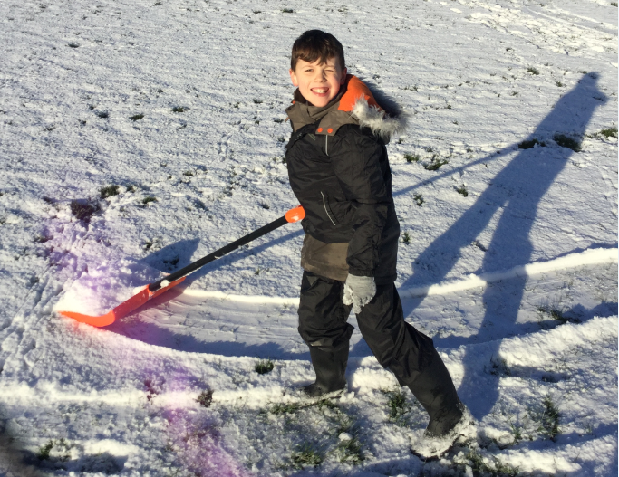 |  | FEJS  - NEWSLETTER  - 27.02.19

Fun in the Snow! ! Our Forest Schools team brave the weather!

appy New Year!
Welcome back everyone!
Welcome back to the second half of the spring term!
Learning together
Throughout the spring term, the children have been focusing on a number of life learning skills. As well as learning about how to stay safe on line [we hope you all liked the school’s pledge which can be seen on our school website!] we have been focusing on our PSHE theme of relationships.
This has led us to change our school rules – we now have only one:
‘The use good manners’
The children felt that this covered everything we needed in order for school to be safe and happy learning environment-I think they’re right!
As part of our focus on developing relationships, we have bought lots of lovely activities for the children to use at playtimes and play together with. We’ve also organized house teams for the children so as to encourage them to work in teams as well as encouraging children to work with partners in the classroom and as small groups of children, in order to share their learning and feel confident to ask and answer questions.
As parents, it’s important that you get your chance to play a

part too. So, this term, they’ll be more parents events [class assemblies/curriculum events] and even a family quiz night!
Here is a list of important dates for you.
8th March at 2pm – Family coffee afternoon with quiz.
11th April from 2pm onwards – Parent’s Evening
12th April at 4pm – Easter Disco

Please see attached sheet for further dates of events throughout the year.

Thank you for your continued
support!

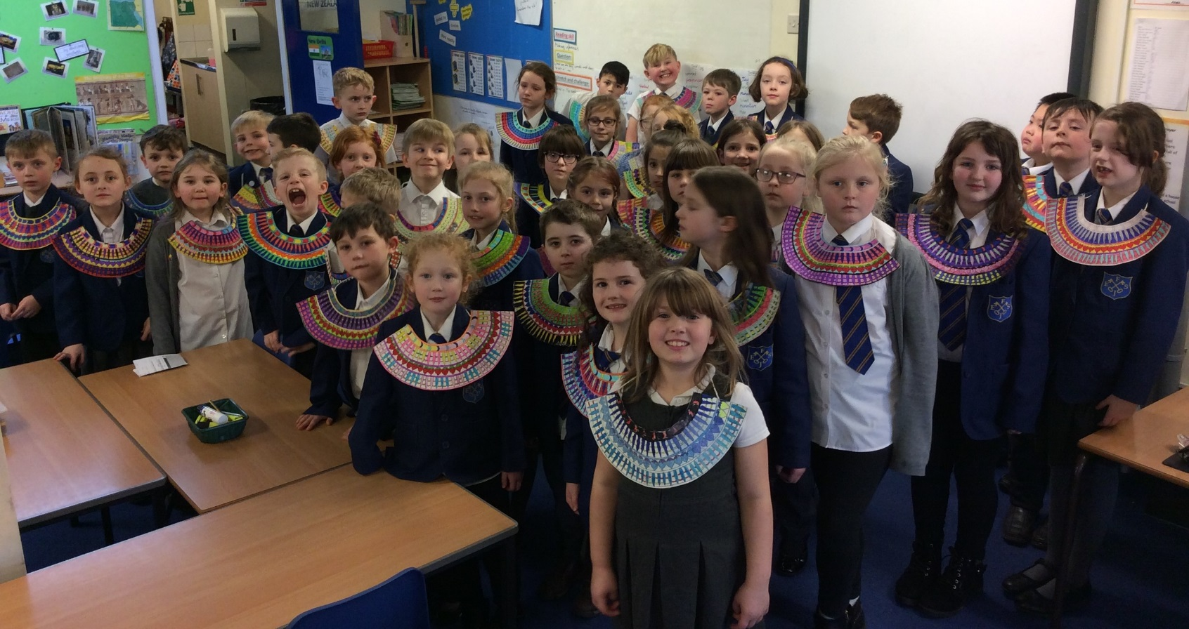
– The Queen’s Party.
14th – Assembly at 10.45 with PDSA.
16th – New uniform Fashion Show after school parents welcome.
20th – Assembly with Buxton Baths [safety and swimming].
24th – Year 2’s to visit FEJS for the day.
28th – 2pm and 6pm meeting for infant parents.
29th – St. Peter’s Day.
30th – Buxton Public Speaking Competition parents of children participating welco
Year 3 children put on a wonderful afternoon for parents, celebrating their topic on the Egyptians! Thank you to all the parents who were able to attend.
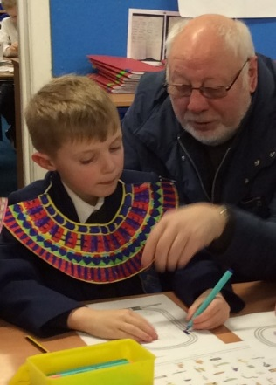
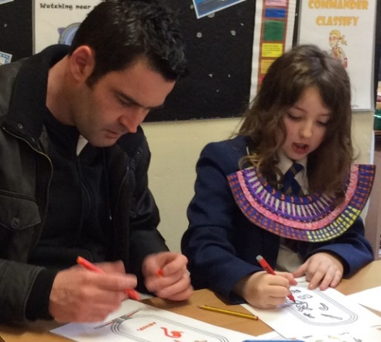
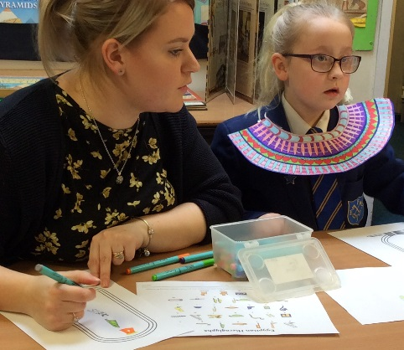
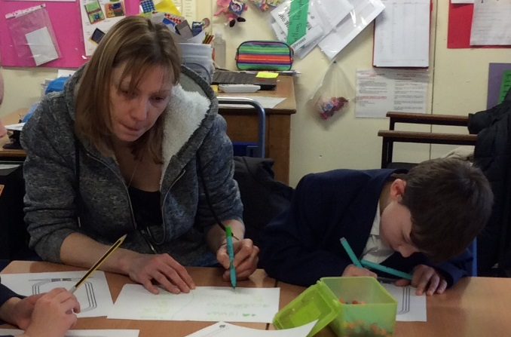

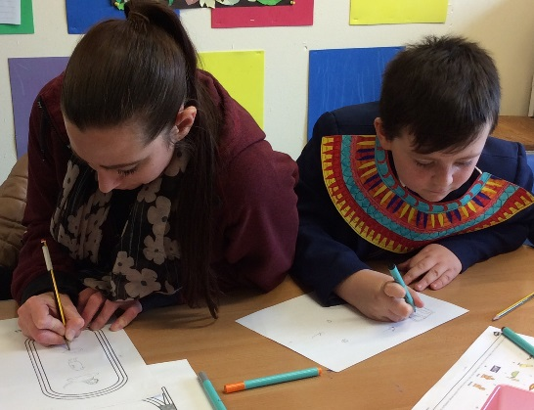
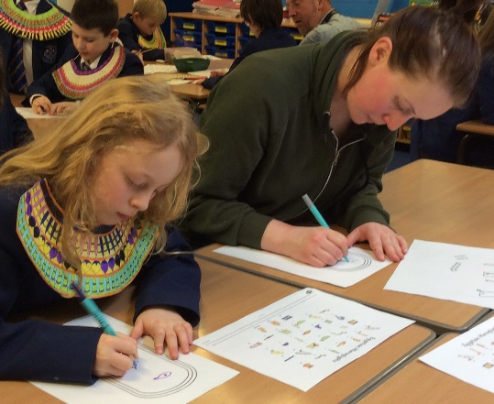
The children,with parents and grandparents, worked together writing their names in Egyptian hieroglyphs [the formal writing systems of the Ancient Egyptians, hiero meaning holy]. Most of the pictures stand for the object they represent, but usually they stand for sounds.
Having fun writing!
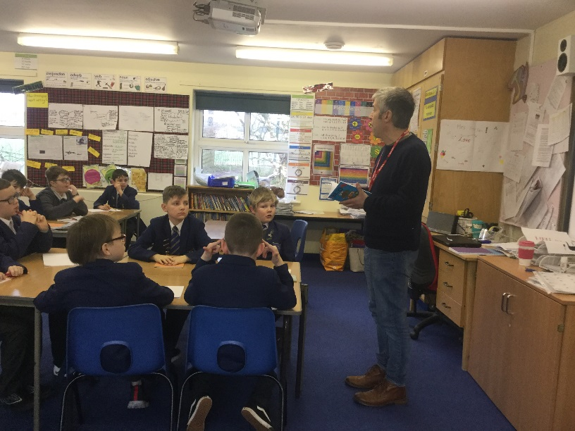
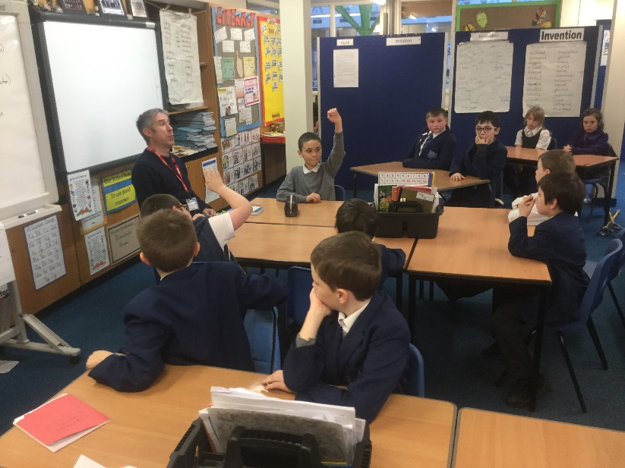
Last term saw the infamous Andy Tooze working on developing a poetry anthology with some of the older children in the school. This term, it will be the younger children’s turn to experience the encouragement that is Andy Tooze – anyone can write poetry!
The Shark
Have you ever seen a shark
SNAP! SNAP! SNAP!
Camouflaging in the deep blue sea?
SNAP! SNAP! SNAP!
Eating fish, hunting and more,
SNAP! SNAP! SNAP!
Mind blowing!
Mr. Hop
Frogs hopping all day long,
Frogs splashing in the pond,
Frogs skipping on the lili pads,
Amphibians who prefer the water,
Oh frogs, frogs you are nice,
Frogs, you started my U Tube life!

Here are a couple of poems from the day.

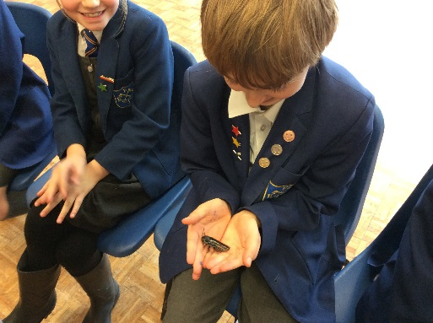
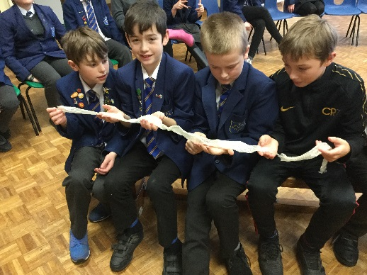
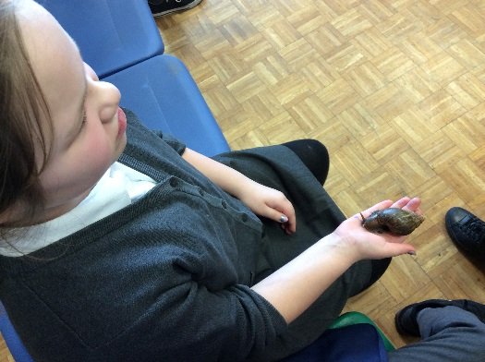
Year 6 ‘hands on’ experience of creatures from the Amazon! The children examine a snake’s shedded skin, a giant snail and what appears to be a giant cockroach!
Don’t forget, your views count and help us to improve or re-think the way we do things. Please ring me or call in for a chat if you wish to complain, query, suggest or complement the school. We work with the best of intentions but sometimes might get things wrong. Our relationship with you is important!

