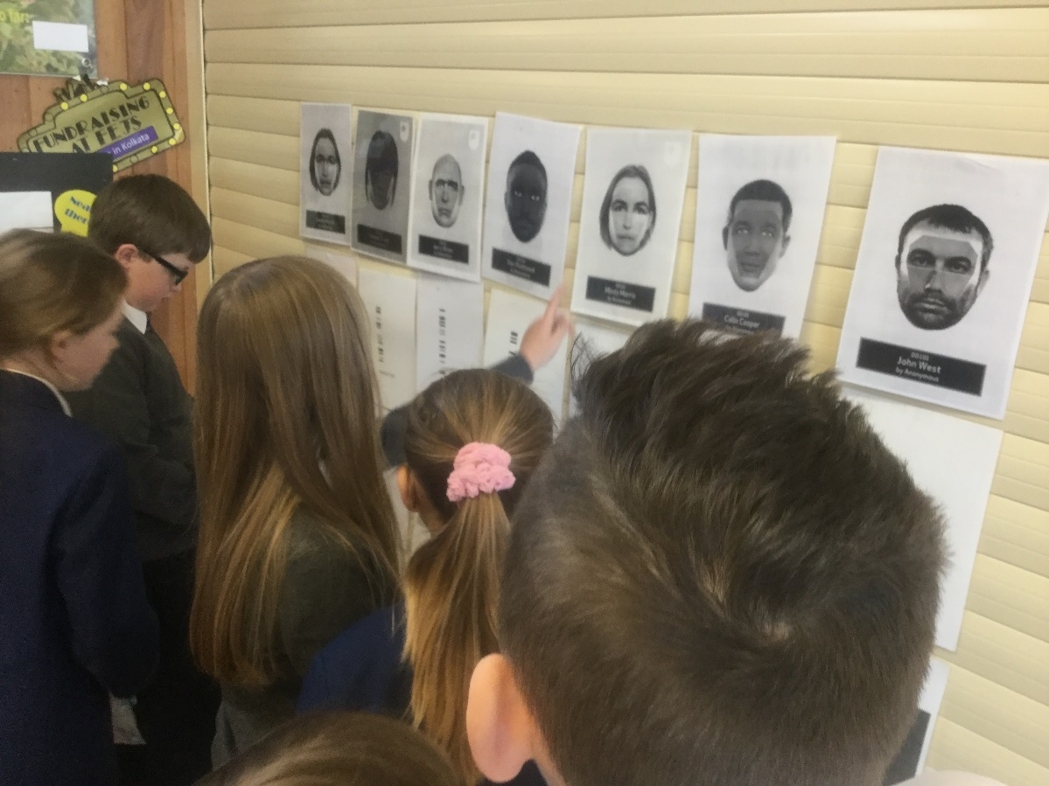 |  | FEJS  - NEWSLETTER  - 29.04.19

Science Week in mARCH: Taking a CLOSER look at Forensic Science IN ACTION!

appy New Year!
Hurray for summer!
Welcome back, everyone, to the summer term of 2019!
Parent’s Evening
Thank you to all those who attended Parent’s Evening last term. It was lovely to see so many of you!
During the evening many of you completed a questionnaire. This was really useful to gage your opinion about the school, identify what we do well and how we can improve.
Out of the 75 completed forms:
99% of you said that your child was happy at school.
99% of you said that your child felt safe at school.
99% of you said that your child is making good progress.
100% of said that your child is well looked after.
100% said that your child is taught well.
97% of you said that your child receives homwwork that helps their child learn.
100% of you said that the school ensures its pupils are well behaved.
96% of you said that the school deals effectively with bullying.
100% of you said that the school is well led and managed.
96% of you said the school responds well to concerns.
99% of you said that you receive valuable information about your child’s progress.
100% of you said that you would recommend the school to others.
Some of you left comments too which we will address.
Communication
A couple of parents mentioned that communication could be improved.
Resources
One parent mentioned that more reading materials were needed for their child.
School website
A couple of you mentioned that they had difficulty locating the calander/diary dates from the school website.
Action:
We’ve ordered more reading materials.
Communication with parents is on the staff meeting agenda this week.
Myself and Miss.Pettett are met with a website provider to discuss more reliable options for improved communication with parents.

THE CURRICULUM
Reading for Pleasure
Reading for pleasure is so important and here at Fairfield we want all children to pick up a book and simply enjoy the read.
Reading is your child’s key to success and what they learn at primary school provides them with secure foundations for high school.
Children choosing to read for pleasure, at home and at school, will be a massive focus this term. We’ll celebrate the successes with the children and reward and encourage them as best we can and we ask that you do the same at home.
If you struggle at home to provide books, especially during the holidays then please remember, we have lots!
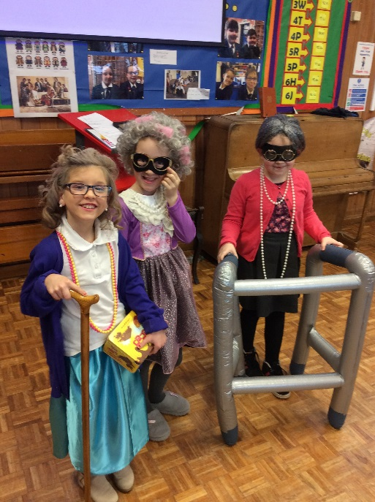
World Book Day 2019!
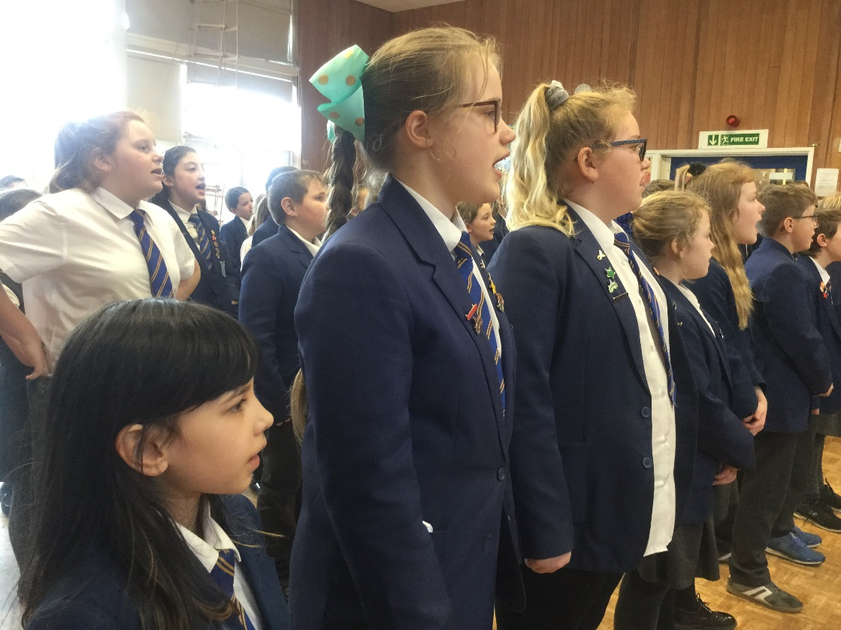
SAFEGUARDING
During the spring term our school had the opportunity to learn about internet safety with a roadshow company and musical charity called POP UK.
The children later recorded songs linked to internet safety which can be heard on the homepage of the school’s our website. Enjoy!
------------------------------------
The staff and governors have recently undergone extensive training in safeguarding. All staff in school are trained to a high standard in Safeguarding Children and Child Protection; Prevent and FGM.
Mrs.Mercer, Mrs.Parkes and Miss.Mellor are the schools Designated Safeguarding Leads.
Should you wish to talk to us, please do not hesitate to pop into school where either myself, Miss.Mellor or Mrs. Parkes will make ourselves available to speak with you.
---------------------------------

You may have noticed signs up at the front door asking parents to switch off mobile phones whilst in school? This is for safeguarding purposes.
Photographs and videos are still allowed at events so long as they are not shared with anyone else but this policy is currently under review.
If videos and pictures are shared without permission, you can be personally liable and fined £25,000 as a result under new data protection laws [called GDPR].
---------------------------------------
Please, please, please let us know if your child is going to be absent from school. We text parents of absent children before 9.15 and follow up with phonecalls by 9.45am. If ‘no contact’ continues, your child’s absence may be referred to the Educatiion Welfare Officer or even the police so it’s crucial you let us know.
STAFFING NEWS
Mr. Pickering, our Caretaker, has left to take up a new post in Derbyshire. We wish him well and every success in his new role.
Mr. Bowers will be taking over temporarily as Buildings Manager.
UNIFORM
Reminder to all that the uniform is required to be worn daily. Obviously, in the summer months, children may not need jumpers or cardigans but the rest of the uniform is still expected to be worn.
School dresses can also be worn, as many parents have asked this question recently.
FUNDRAISING
A massive ‘tahnk you’ to all who attended our school disco and for making it such a success. We raised just over £500!
Much of the money raised goes towards play equipment for the children but we’re hoping that, by the end of the year, we’ll be able to buy a school radio.
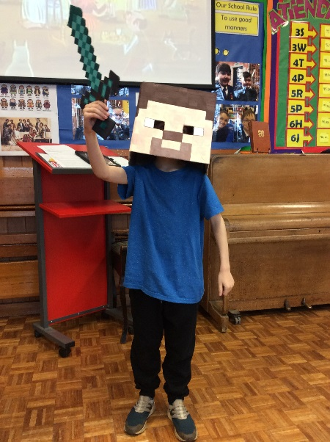
More World Book Day pictures 2019!
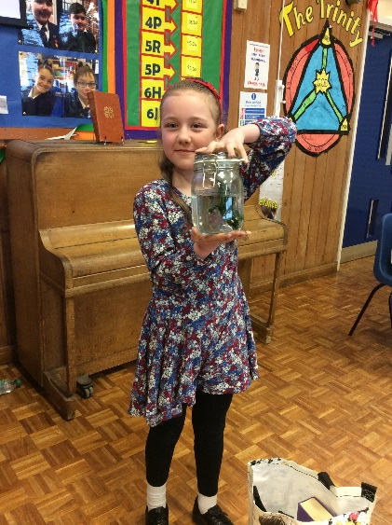
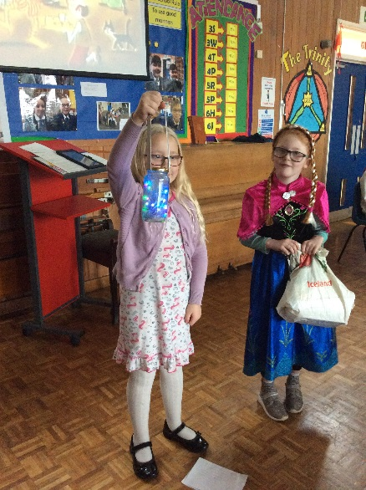
– The Queen’s Party.
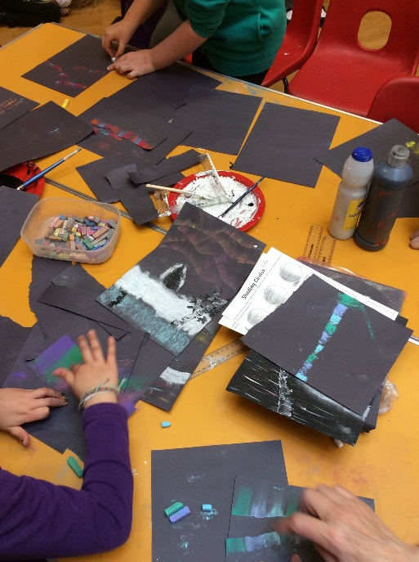
14th – Assembly at 10.45 with PDSA.
16th – New uniform Fashion Show after school parents welcome.
20th – Assembly with Buxton Baths [safety and swimming].
24th – Year 2’s to visit FEJS for the day.
28th – 2pm and 6pm meeting for infant parents.
29th – S 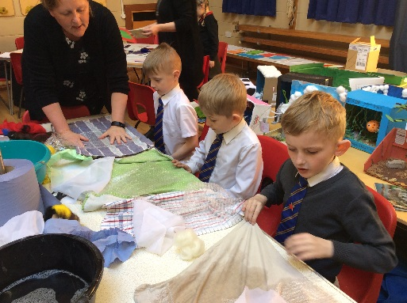t. Peter’s Day.
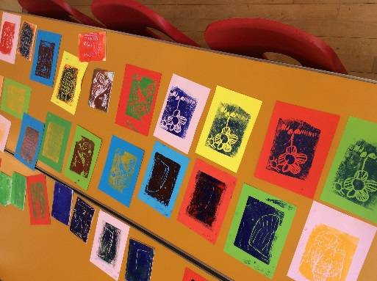
30th – Buxton Public Speaking Competition parents of children participating welc
Working towards Arts Award for schools
Children in Years 3 and 4 were invited to attend an afternoon of art at the New Mills Centre. This links to our drive to achieve an Arts Award for the good work we do in the wider curriculum. Many thanks to the children who enjoyed the day and to the staff for their organization.

DIARY DATES
May 2019
8th & 9th – Hands on Hoards visit to Buxton Museum for Year 3
13th – SAT’s week
13th – Christian Aid Week
17th – Global Neighbour’s Day for Christian Aid Week – Families invited in for Afternoon Tea in from 2pm.
21st – Some children from Year 3 and 4 attending Modern Slavery Ambassad0rs training
22nd – Kwik Cricket
23rd – Year 5 event for parents – Ukulele concert at 2.30pm
24th – school ends for half term
June 2019
3rd – school starts
4th - Road Safety for Year 6 pupils – in preparation for their journey to high school in September
4th – Hands on Hoards at Buxton Museum for Year 6 pupils
10th – Healthy Eating Week
12th – Quad Kids
12th – Healthy Eating Day [more info to follow] Parents invited to join in the fun with their children.
12th & 13th - Hands on Hoards visit to Buxton Museum for Year 4 pupils
13th – Open the Book Assembly
20th – Our School Governor for safeguarding in school to interview the School Council
26th – Yea 3 and 4 football-more information to follow
July 2019
8th – Swimming Gala-more information to follow
9th – Transition day [Year 2 children visiting the juniors] during the morning
11th – Open the Book Assembly
12th - School summer disco 4.30pm til 6pm
15th – Full Governors Meeting
18th – Awards Celebration for Years 3 & 4 at 2pm
Awards Evening for Years 5 & 6 at 5.30 pm
19th – Year 6 Leavers Assembly at St. Peter’s Church at 9.45am
19th – Year 6 PROM at 5pm.
22nd – School ends

